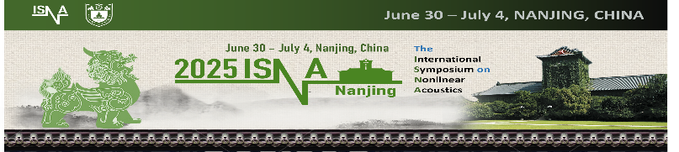

2025 ISNA Sponsorship

Yes! I would like to make a contribution on behalf of my organization.

Sponsorship Levels
Gold Sponsor - $15,000
• Free registration for 6 people (including invitations to reception)
• Full page, full color advertisement on first pages of the digital abstract book
• Full page, full color advertisement in program booklet
• Logo on symposium website, and sponsors page in program booklet and digital abstract book
• 6 x 4 meter (20 x 13 ft.) exhibit space
• Opportunity to give 1 oral lecture at special scientific sessions

** Cover positions will be assigned on a first come basis by the date the signed support is received.

Silver Sponsor - $7,500
• Free registration for 4 people (including invitation to reception)
• Full page, full color advertisement in the digital abstract book
• Full page, full color advertisement in the program booklet
• Logo on symposium website, and sponsors page in program booklet and digital abstract book
• 6 x 2 meter (20 x 6.5 ft.) exhibit space

Bronze Sponsor - $5,000
• Free registration for 2 people (including invitation to reception)
• Half page, full color advertisement in digital abstract book
• Half page, full color advertisement in program booklet
• Logo on symposium website, and sponsors page in program booklet and digital abstract book
• 3 x 2 meter (10 x 6.5 ft.) exhibit space

Additional Sponsorship Opportunities:

Reception sponsorship - $5000
• Your company banners and other printed material (brochures etc.) will be presented in the reception hall and on the tables.
• Logo on the sponsors page
• Half page full color advertisement (printed and digital)
• Free registration for 4 people (including invitation to reception)

For more details on sponsorship packages - please contact: 2025isna@gmail.com .

2025 ISNA Sponsorship Support Form

Contact Info:
Company Name
Contact*
Email
Phone
Address
City, State, ZIP Code
Country
*This is a person we will be contacting to coordinate the sponsorship and who will receive the sponsorship kit.

Payment in full is due on Apr 30th, 2025.

Please remit the Sponsorship Support Form to:
Institute of Acoustics, Nanjing University
Attn: Suyu Ding
isna2025@gmail.com

